Machine learning-based discrimination and exploration of high-, intermediate-, and low-sulfidation epithermal gold deposits using pyrite trace element geochemistry.

Abstract:
Epithermal gold deposits constitute one of the world's most important gold resources, and the discrimination of high-sulfidation, intermediate-sulfidation, and low-sulfidation deposit subtypes is central to deciphering the metallogenic conditions of such deposits and guiding mineral exploration. The trace-element compositions of pyrite provide important constraints on ore genesis. However, the trace-element signatures of pyrite from high, intermediate, and low-sulfidation deposits overlap considerably, making it difficult to distinguish specific deposit types using conventional approaches. In this study, seven machine-learning models—support vector machine (SVM), multilayer perceptron (MLP), TabPFN, HyperFast, FT-Transformer, TabR, and CatBoost—were applied to analyze 2,269 pyrite trace-element datasets collected from 17 representative high-, intermediate-, and low-sulfidation deposits worldwide to discriminate different deposit subtypes. The results demonstrate that all models achieved high accuracy (>93%) in distinguishing deposit types, with TabPFN, CatBoost, and FT-Transformer performing particularly well, achieving accuracies exceeding 95%. SHAP analysis revealed that Cu, Au, Mo, Sb, Te, and Ni are the core discriminant elements for classification. This study demonstrates that machine-learning-based, data-driven approaches can provide a robust basis for distinguishing subtypes within the same deposit type, understanding ore-forming mechanisms, and formulating exploration strategies.

Keywords: pyrite trace elements; epithermal deposit subtypes; machine learning; deposit type classification; SHAP analysis

1. Introduction
Epithermal gold deposits are among the most important gold deposit types in global metallogenic systems, characterized by large resource volumes and high economic value, and they have long been a primary research focus in gold exploration (Richards, 2011; Sillitoe, 2010; 陈衍景 et al., 2007). Previous studies have classified epithermal gold deposits into three end-member types—high-sulfidation (HS), intermediate-sulfidation (IS), and low-sulfidation (LS)—based on ore-fluid properties, sulfur fugacity, and ore-forming physicochemical conditions (Cooke and Simmons, 2000; Hedenquist et al., 2000); however, the genesis of intermediate-sulfidation deposits remains controversial (Wang et al., 2024a; Wang et al., 2019). Some researchers argue that, from low-sulfidation to high-sulfidation, the pH and oxygen fugacity ($f_{O_{2}}$) of the fluids vary continuously and the mineral assemblages change gradationally, so that the boundaries among the "intermediate-sulfidation," "high-sulfidation," and "low-sulfidation" types are ambiguous (Einaudi et al., 2003). In contrast, based on studies of numerous deposits, other researchers have proposed that IS deposits are not simple transitional products; rather, they possess independent and reproducible ore-forming tectonic settings, alteration–mineralization zoning, and fluid evolution paths, representing the products of a specific geological process (Börner et al., 2021; Sillitoe, 2010; Zhang et al., 2024c). At present, the identification of epithermal gold deposit subtypes relies mainly on petrographic observation, fluid inclusion analysis, and traditional multivariate geochemical statistical methods (Christie et al., 2007; Mauk and Simpson, 2007). Such approaches are highly dependent on the geologists' practical experience and suffer from low discriminative efficiency and substantial subjective bias. Conventional low-dimensional discrimination diagrams exhibit significant overlap, making it difficult to distinguish deposit types directly; on the phase diagrams of the pH, oxygen fugacity（$f_{O_{2}}$）, and sulfur fugacity（$f_{S_{2}}$）of ore-forming fluids in epithermal gold deposits, the boundaries between the intermediate-sulfidation (IS) type and the other end-members are blurred, precluding direct classification into a distinct type (Heinrich, 2005; Wang et al., 2019). favors the formation of stable tellurium complexes. Therefore, how to accurately and quantitatively discriminate the subtypes of epithermal gold deposits remains an urgent problem to be solved.
In recent years, numerous researchers have attempted to combine mineral trace-element geochemistry with machine learning to quantitatively classify mineral deposits. For example, Zhang et al. (2022) used the traditional models random forest (RF), support vector machine (SVM), and multilayer perceptron (MLP) to classify magnetite from different deposit types and achieved considerable accuracy; Zeng et al. (2025) used the ensemble model XGBoost to classify sphalerite from different types of hydrothermal deposits, attaining an accuracy of >95%; Zhang et al. (2024a) used deep neural networks (DNN) to perform three-level classification of chalcopyrite by deposit type, ore type, and ore texture, reaching an accuracy as high as 98%. Studies have shown that traditional models such as random forest (RF), support vector machine (SVM), and multilayer perceptron (MLP) perform well in classification (Caraballo et al., 2025; Meng et al., 2024; Sun and Zhou, 2022), while emerging models such as ensemble algorithms (XGBoost) and deep neural networks (DNN) also demonstrate promising application prospects (He et al., 2026; Wang et al., 2024b). As a powerful interpretability tool, SHAP (SHapley Additive exPlanations) analysis enables researchers to deeply explore the internal logic of trained models, thereby providing reliable auxiliary decision support for refined geological-genesis analysis (Wang et al., 2024b; Zeng et al., 2025; Zhang et al., 2024a; Zhang et al., 2024b).
Pyrite is the most widely distributed sulfide in epithermal gold deposits. Its trace-element composition is highly sensitive to changes in ore-forming physicochemical conditions and can completely record the evolution of ore-forming fluids, making it an important indicator for discriminating epithermal deposits (Guan et al., 2025; Steadman et al., 2021). Existing studies have mostly focused on using pyrite trace elements to distinguish epithermal gold deposits from other major deposit classes (Mondal et al., 2026; Zhang et al., 2024a; 邓依 et al., 2024), whereas few scholars have fully explored their internal subtypes, particularly the intermediate-sulfidation transitional subtype. Meanwhile, an assessment of the applicability of the various technical-paradigm models that have emerged in tabular data processing within the artificial intelligence field in recent years remains lacking for geochemical data.
In this study, we collected 2,269 pyrite geochemical datasets measured by laser ablation–inductively coupled plasma–mass spectrometry (LA-ICP-MS) from 17 representative high-, intermediate-, and low-sulfidation epithermal gold deposits worldwide and introduced a low-concentration feature indicator. Based on these data, a horizontal comparative experiment was conducted on two classical machine learning algorithms (SVM, MLP) and five machine learning algorithms representing different technical paradigms for tabular data (TabPFN, HyperFast, FT-Transformer, TabR, CatBoost). All models successfully distinguished the above deposit types with high classification accuracy. Meanwhile, the SHAP algorithm was used to investigate the geological interpretability of the classification decisions of the optimal model so as to evaluate whether it can provide genetic insights into key elements for practical research. This study aims to identify, through pyrite trace-element-based machine learning, a model capable of effectively distinguishing the subtypes of epithermal gold deposits, thereby providing support for research on ore genesis and mineral exploration.

2. Data and methods
All models in this study were constructed using PyCharm in a Python 3.11 environment. The third-party libraries used for data processing and model training include Scikit-learn, PyTorch, Matplotlib, NumPy, Pandas, and SHAP, among others. The overall technical workflow is shown in Figure 1.
Figure 1. Machine learning discrimination workflow for high-, intermediate-, and low-sulfidation epithermal gold deposits based on pyrite trace elements

2.1. Data source
In this study, we systematically compiled and summarized pyrite trace-element data from 17 epithermal gold deposits, comprising a total of 2,269 valid samples and 39 ore-related trace elements including Co, Cu, As, and Au. Among them, there are 848 samples from high-sulfidation deposits, 587 from intermediate-sulfidation deposits, and 834 from low-sulfidation deposits, with an overall roughly balanced sample distribution. The names, locations, sample numbers, and literature sources of the high-, intermediate-, and low-sulfidation deposits are listed in Appendix Table 1. All pyrite trace-element data collected in this study were obtained using laser ablation–inductively coupled plasma–mass spectrometry (LA-ICP-MS), and signal intervals affected by the mineral matrix and fluid inclusions were removed during analysis to ensure data quality. For data at the limit of detection (LOD), the original LOD values reported in the literature were preferentially adopted; when no explicit LOD was reported, a conservative statistical principle was applied, taking $\frac{1}{\sqrt{2}}$ of the minimum value of the corresponding element as the empirical upper limit (Hornung and Reed, 1990).

2.2. Machine learning methods
Machine learning methods can perform effective class prediction based on multidimensional input features. In this study, the task was formulated as a mutually exclusive multiclass classification problem, in which each pyrite sample is assigned a unique class label (high-sulfidation, intermediate-sulfidation, or low-sulfidation). To address this multiclass task, seven supervised learning methods were integrated: MLP, SVM, TabPFN, HyperFast, FT-Transformer, TabR, and CatBoost. The two classical supervised models, MLP and SVM, were selected as baselines representing traditional methods (Gul et al., 2025; Qin et al., 2023). In addition, five models of different technical paradigms that have demonstrated excellent performance in recent years—TabPFN (prior-based foundation model), HyperFast (automated machine learning), FT-Transformer (deep learning), TabR (memory-based reasoning), and CatBoost (ensemble learning)—were selected to evaluate the suitability of novel algorithms for geochemical data (Barkov et al., 2026; Cherid et al., 2025; He et al., 2026; Jaffari et al., 2024; Luo et al., 2025; Mondal et al., 2026), to screen the optimal algorithm best suited to this dataset. For all models requiring hyperparameter tuning, grid search was employed for hyperparameter optimization (Table 1). The algorithms of each model are presented in Appendix 1.
Table 1. Parameter settings
Methods | Parameters
MLP | hidden_layer_sizes = (224, 160), dropout_rate = 0.083244, lr = 0.000223, weight_decay = 0.000041, batch_size = 16
SVM | C = 10, kernel = rbf, gamma = auto
TabPFN | No Parameters
HyperFast | n_ensemble = 16
FT-Transformer | d_model = 256, n_layers = 3, n_heads = 8, dropout = 0.1, lr = 0.001, d_ff = 1024, lr_factor = 0.3, lr_patience = 5
TabR | mlp_hidden_dims = [128, 128], dropout = 0.1, lr = 0.0005, lr_factor = 0.3, lr_patience = 8, k_retrieval = 5, aggregation = concat
CatBoost | No Parameters

2.3. Models construction

2.3.1. Data pre-processing and optimization
（1）Data Preprocessing
Data preprocessing can improve data quality and ensure the training quality and generalization ability of machine learning models. To preserve low-concentration information, a feature indicator mechanism was designed in this study: points that are subject to detection-limit constraints or have zero values were systematically flagged in the Indicators worksheet; these flags were then converted, together with the effective detection-limit values in the LOD worksheet, into binary indicator variables with the same dimensionality as the original data, which were subsequently concatenated onto the original element feature vectors as augmented features. Next, a base-10 logarithmic transformation was applied to the numerical features, and null values, zero values, and values below the limit of detection (LOD) were uniformly converted into missing values.
（2）Feature Selection
Because of differing research emphases, different datasets contain different sets of elements, resulting in severe missingness for some elements. Studies have shown that even if highly correlated features each possess strong predictive power for the classification target, retaining them simultaneously can still lead to degraded classification performance and reduced generalization ability (Yu and Liu, 2004). When the feature missingness rate exceeds 70%, imputation can introduce severe distortion (Junaid et al., 2025). Therefore, it is necessary to strike a balance between geological significance and algorithmic requirements when selecting appropriate features for model training.
（3）Missing-Value Handling
Most traditional pattern classifiers require handling of missing values to enable model training (Emmanuel et al., 2021; García-Laencina et al., 2009). MissForest is a non-parametric missing-value imputation method based on random forest that does not rely on normal distributions, linear relationships, or a specific parametric model, making it suitable for datasets with strong complex interactions and nonlinear relationships (Stekhoven and Bühlmann, 2012). It has already been applied to the imputation of geochemical data (Abildin et al., 2023; Luo et al., 2024; Sun et al., 2023). During the iterative process of the algorithm, the aforementioned feature indicators were fully exploited: the flagged points were entered into the computation with half of their corresponding detection limits as initial estimates, guiding MissForest to more accurately recover the values through iteration.
（4）Data Set Partitioning
Studies have shown that stratified ten-fold cross-validation performs best in improving stability and maintaining low bias (Kohavi, 1995). In this study, the dataset was stratified by class; within each class, samples were randomly partitioned into ten mutually exclusive subsets, and the corresponding subsets with the same fold index from all classes were then combined into a complete training set (9 folds) or test set (1 fold). In each iteration, the training set was used for model training and parameter tuning, and the corresponding test set was used to evaluate the model. During machine learning modeling, if the model inadvertently encounters information from the test set, resulting in information leakage, the evaluation metrics will be inflated (Kapoor and Narayanan, 2023; Kaufman et al., 2012). Accordingly, duplicate samples were removed from the dataset, and MissForest was trained on the training set and used for imputation of the test set. It is worth noting that the imputation model (MissForest) and CatBoost are homogeneous models, and the algorithm also has native missing-value handling capability. Therefore, this model was trained and tested directly on the original data without imputation.

2.3.2. Model evaluation
The accuracy and interpretability of a classification model are important indicators for evaluating whether the model can be generalized for practical use. In this study, accuracy, precision, recall, F1-score, AUC, and the Corrected Resampled t-Test were used to benchmark the models' performance (Appendix 1), and SHAP was employed to measure the average marginal contribution of each feature to the model's discrimination of different classes. Studies have shown that high generalization accuracy and robustness on the validation set are important prerequisites for the trustworthy interpretability of black-box models; feature importance captured through statistical fitting (such as SHAP values) does not necessarily reflect the true causal mechanisms in reality, and must be cross-validated against real-world context and domain knowledge (Crabbé and Schaar, 2023; Rudin, 2019). Hence, under the premise of ensuring statistical reliability, to evaluate the reasonableness of the models' decision-making behavior, candidate models with high accuracy (>95%) were selected in this study for noise robustness testing and SHAP contribution analysis.

3. Results

3.1. Trace elements characteristics of pyrite
The original dataset in this study comprises 39 trace elements. After screening by missingness rate, 13 core elements (Ag, As, Au, Bi, Co, Cu, Mo, Ni, Pb, Sb, Se, Te, Zn) were retained; except for the extremely high correlation between Se and Te in the intermediate-sulfidation dataset (p=0.99), the correlations among the remaining features were all below 0.95. Given that the variance of Se (0.35) is much lower than that of Te (0.76), and that the ionic radius of Se is extremely close to that of S, allowing it to be readily co-precipitated with S in various sulfides, Se is a less sensitive indicator in fluids than Te (Queffurus and Barnes, 2015; Rouxel et al., 2002; Vikent’ev et al., 2019). Therefore, 12 elements—Ag, As, Au, Bi, Co, Cu, Mo, Ni, Pb, Sb, Te, and Zn—were selected for subsequent modeling and analysis. As revealed by the distribution of pyrite trace elements (Figure 2), the concentration ranges, medians, and degrees of dispersion of trace elements differ significantly among high-sulfidation (HS), intermediate-sulfidation (IS), and low-sulfidation (LS) deposits: HS deposits are characterized by pronounced enrichment in Cu (0.3–9,122,389 ppm; mean 224,052 ppm), Bi (0.0048–44,763 ppm; mean 897 ppm), and Te (0.02–169,856 ppm; mean 1,987 ppm), with overall high element contents and strong dispersion; LS deposits exhibit dominant As (0.027–473,339 ppm; mean 12,491 ppm), Au (0.005–1,581 ppm; mean 63 ppm), and Sb (0.014–12,712 ppm; mean 161 ppm), with notably low Cu content (0.044–48,950 ppm; mean 562 ppm); IS deposits have the lowest contents of most elements (Co, Ni, Mo, Sb) among the three types, with Cu contents similar to those of LS deposits and both far below those of HS deposits. In addition, some elements exhibit outliers, which may reflect heterogeneous local fluid activity and large differences in mineralization intensity during ore-forming processes (Agterberg, 2012; Cheng, 2012; Zhao et al., 2016).
Scatter plots of element contents further reveal the element-assemblage differentiation patterns among the different deposit types (Figure 3). In binary diagrams, the boundaries among the three deposit types exhibit a large number of overlapping samples, making it difficult to precisely delineate deposit samples and impossible to achieve accurate discrimination of the three deposit types. Furthermore, the element correlation heatmap shows strong positive correlations for some element pairs, such as Co–Ni and Sb–Te (Figure 4).
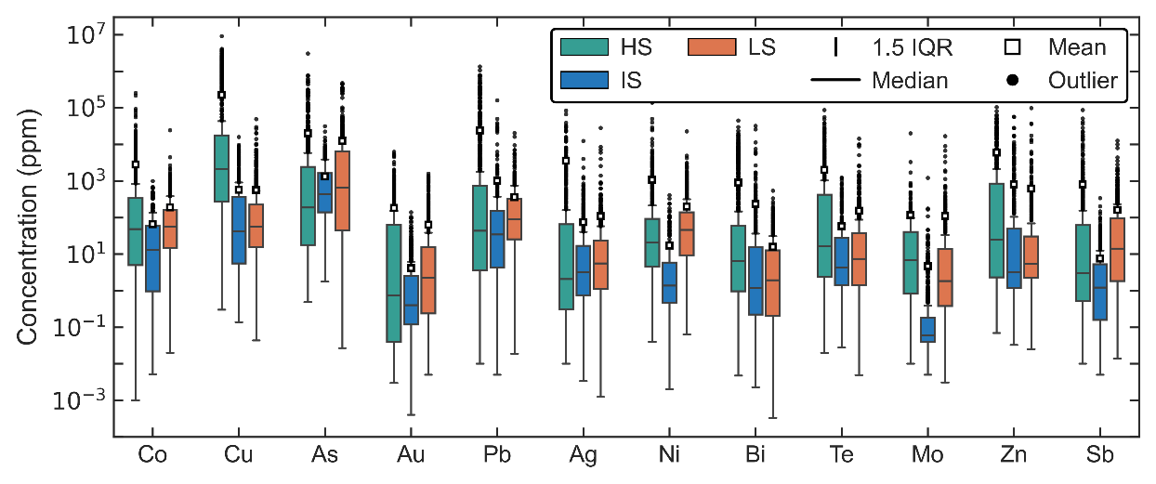 Figure 2 Box plot of pyrite elements
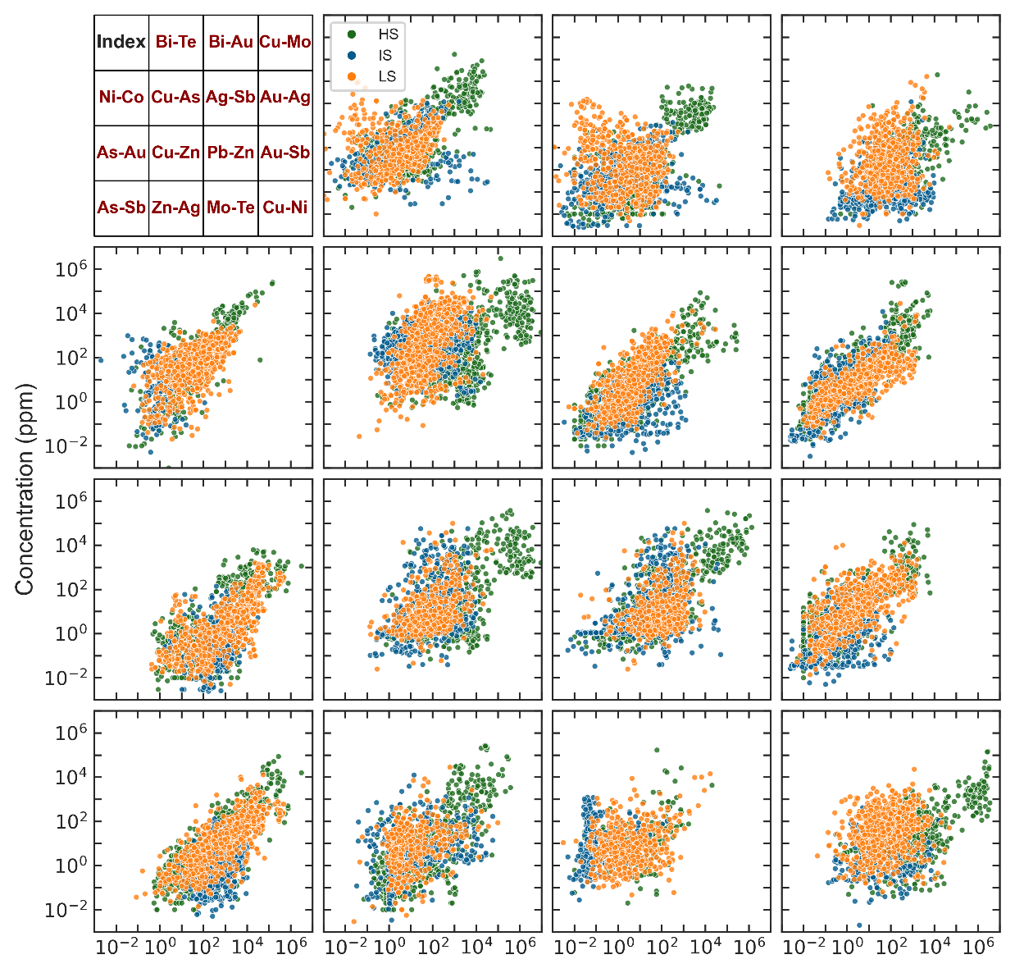
Figure 3 Binary diagram of pyrite element correlations
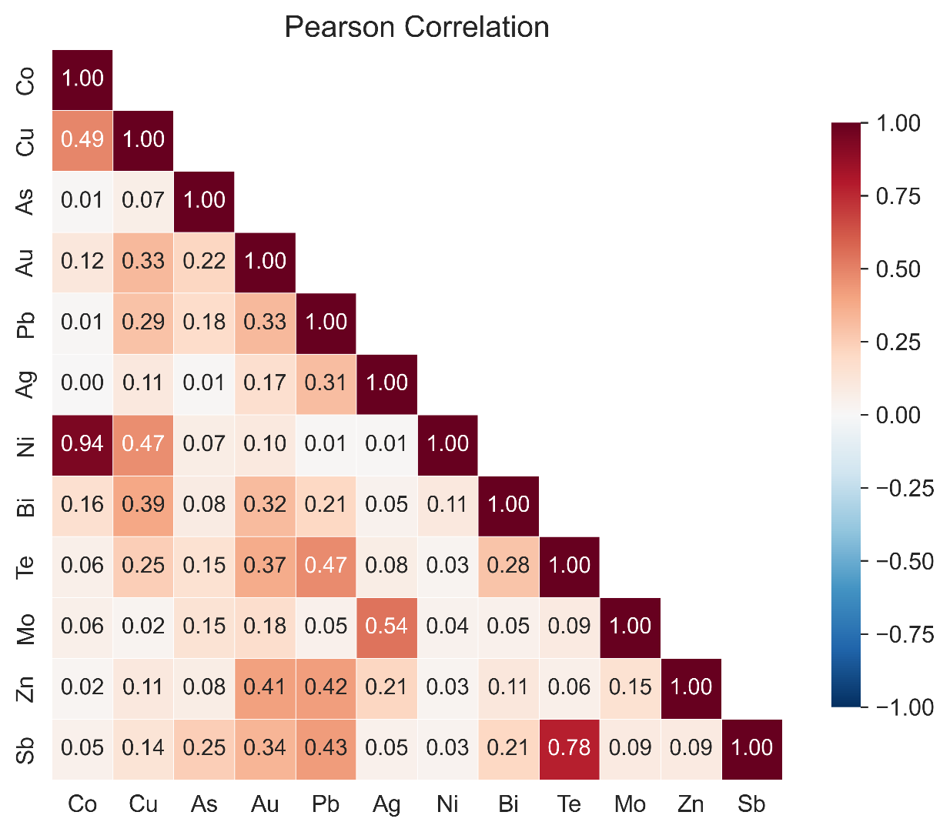
Figure 4 Heatmap of element correlations

3.2. Performance of seven classifier models
The seven machine learning models—SVM, MLP, TabPFN, HyperFast, FT-Transformer, TabR, and CatBoost—all performed well in classifying epithermal gold deposit types. Their performance metrics (accuracy, precision, recall, and F1-score) all exceeded 0.93, and the AUC values remained stably above 0.98 (Table 2). Among them, TabPFN, CatBoost, and FT-Transformer performed most prominently, with accuracies all exceeding 0.95. The Nadeau & Bengio corrected resampled t-test determines the differences among models via the p-value; a smaller p-value indicates a statistically significant difference in model performance. Compared with the other models, the p-values of TabPFN were all close to 0; no significant differences were found between CatBoost and FT-Transformer (p=0.816), or among MLP, SVM, and HyperFast (all p-values greater than 0.7); TabR exhibited certain differences from all the other models (Figure 5).
Table 2. Descriptive statistics of different methods
Method | Accuracy |  | Recall |  | F1 |  | macro-average AUC
 | Mean | Std | Mean | Std | Mean | Std
CatBoost | 0.957 | 0.012 | 0.957 | 0.012 | 0.957 | 0.012 | 0.995
TabR | 0.935 | 0.012 | 0.935 | 0.012 | 0.935 | 0.012 | 0.988
HyperFast | 0.944 | 0.015 | 0.945 | 0.015 | 0.944 | 0.015 | 0.991
MLP | 0.945 | 0.017 | 0.945 | 0.017 | 0.945 | 0.017 | 0.993
TabPFN | 0.998 | 0.004 | 0.998 | 0.004 | 0.998 | 0.004 | 1.000
FT-Transformer | 0.959 | 0.015 | 0.959 | 0.015 | 0.959 | 0.015 | 0.994
SVM | 0.942 | 0.017 | 0.943 | 0.016 | 0.943 | 0.017 | 0.990

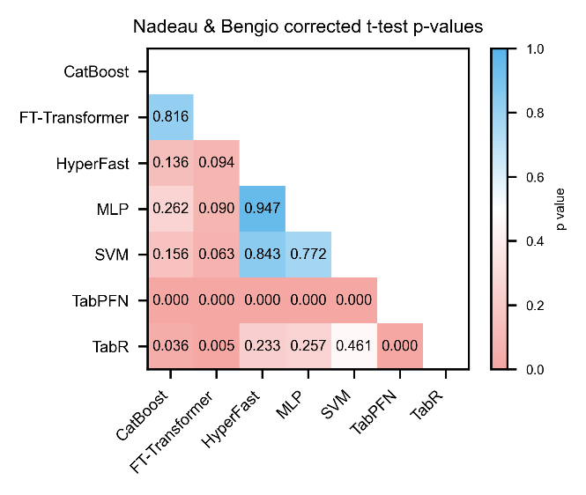
Figure 5 Significance plot of the corrected t-test differences

Integrating the performance metrics and the significance test results, this study selected the three best-performing models—TabPFN, CatBoost, and FT-Transformer—for subsequent noise robustness testing and interpretability analysis.

3.3 Model Noise Robustness Test Results
This study systematically investigated the performance degradation of the TabPFN, CatBoost, and FT-Transformer models under different data positions, noise gradients, and noise types, in order to test the models' dependence on data sources and their noise robustness; the results are shown in Figure 6.
Gaussian random perturbations with standard deviations of 0.01, 0.05, 0.1, and 0.2 were added to the imputed dataset, the original dataset, and the full dataset. The results show that FT-Transformer and CatBoost exhibited extremely small performance degradation across all noise tests, with only slight performance differences under extreme noise conditions. TabPFN showed a marked performance decline when Gaussian noise was applied to the original and full datasets, whereas when noise was applied to the imputed dataset, only weakly significant differences emerged under extreme noise conditions. In the label permutation and Dropout random masking tests (at noise levels of 1%, 5%, 10%, and 20%), TabPFN exhibited the strongest resistance to label noise and the greatest adaptability to incomplete features, maintaining high accuracy even under high-ratio scenarios; CatBoost ranked second; and FT-Transformer was relatively more affected by label errors. In addition, FT-Transformer showed a slight rebound in accuracy under trace-noise conditions, which may be because moderate random perturbation produced a regularization effect that enhanced the capability of the deep learning model (Bishop, 1995; Wager et al., 2013).
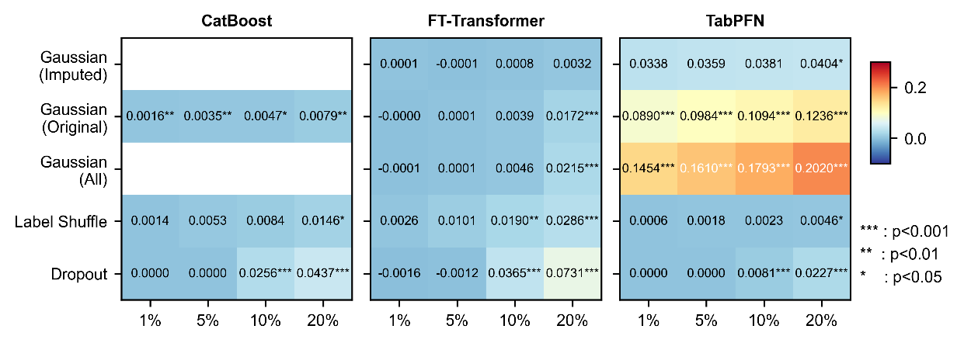
Figure 6 Heatmap of noise robustness

3.4. SHAP analysis of pyrite trace elements
In this study, SHAP interpretation was performed on the three best-performing models (TabPFN, FT-Transformer, and CatBoost). The stacked bar plot reflects the overall contribution of each feature by computing the mean absolute SHAP value of each feature across all samples for the different deposit types (HS, IS, and LS). The mean absolute SHAP values of the features across all samples are shown in Figure 7. Overall, TabPFN identifies Cu, Au, Mo, Sb, and Te as the core trace elements for distinguishing the high-sulfidation (HS), intermediate-sulfidation (IS), and low-sulfidation (LS) epithermal gold deposit types (Figure 7a); FT-Transformer shows relatively high consistency with TabPFN in feature importance (Figure 7b), but relies more heavily on the indicator features, which may limit its sensitivity to the directionality of values when interpreting the positive and negative marginal contributions of individual features; the decision mechanism of CatBoost differs markedly from the former two models (Figure 7c) and is insensitive to indicator perturbations, potentially increasing the risk of neglecting the genetic contribution of low concentrations of key features. At the same time, high accuracy implies that the model accumulates small prediction errors during SHAP analysis, thereby making the decisions based on SHAP more reliable for decision-makers (Guidotti et al., 2018; Hooker et al., 2018; Lundberg and Lee, 2017). Therefore, given that TabPFN achieves the highest accuracy and its SHAP interpretation is the most credible, the SHAP beeswarm plot was used to reveal the average marginal contribution of individual features in the TabPFN model and to explore its interpretability potential.
Figure 7 SHAP importance bar chart of the high-accuracy models
Figure 8 SHAP beeswarm plots for the HS (a), IS (b), and low-sulfidation (c) types.

4. Discussion

4.1 Applicability of the Data and Feature Indicators
In traditional geochemical data processing workflows, data below the limit of detection (LOD) are often ignored or directly discarded, resulting in the loss of low-concentration geochemical signals (Hron et al., 2010; Palarea-Albaladejo and Martín-Fernández, 2015). In epithermal ore-forming systems, however, element concentrations below the LOD generally correspond to weak fluid activity, low sulfur fugacity, or reducing ore-forming environments, and serve as important discriminative criteria for distinguishing low-sulfidation and intermediate-sulfidation deposits(Einaudi et al., 2003; Sillitoe and Hedenquist, 2003). To address this issue, this study constructed binary feature indicators to encode LOD-related information as independent auxiliary features, increasing the model's information utilization so that the continuous variation patterns of element concentrations and the discrete characteristics of elements below the LOD can be captured simultaneously (Figure 9). At the same time, the accuracies of each model before and after the addition of the feature indicators were compared (Figure 10). The results show that the feature indicators can effectively improve the separability of the data, with particularly significant performance gains for SVM, MLP, and FT-Transformer.
Figure 9 Statistics of the data for each deposit type
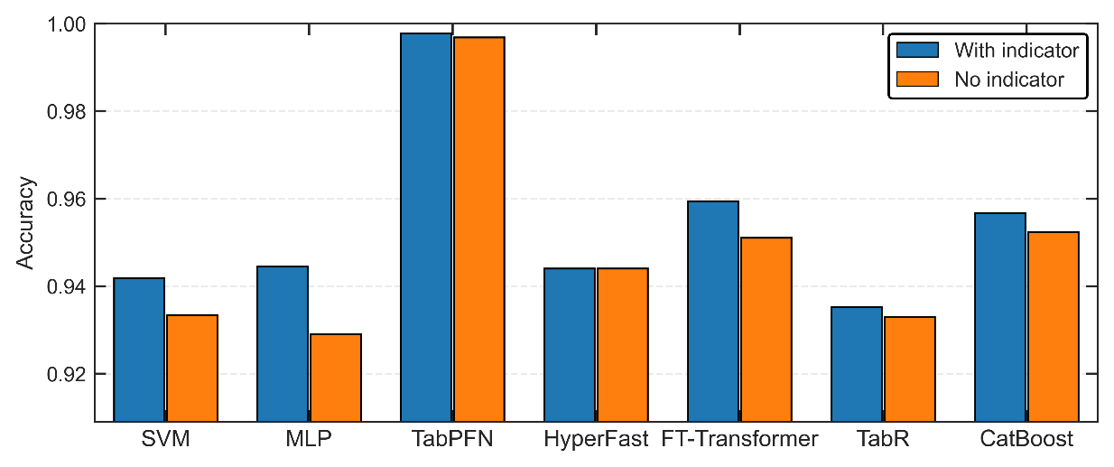
Figure 10 Effect of the feature indicators
Geochemical data of pyrite in hydrothermal deposits are influenced by element migration and enrichment during ore-forming processes, and generally exhibit a markedly positively skewed distribution (Large et al., 2009; Reimann and Filzmoser, 2000). Logarithmic transformation can compress the differences in numerical ranges among elements and attenuate the influence of extreme values, thereby balancing the weights of the elements (Figure 11). This fundamentally avoids classification bias caused by differences in data magnitude, allowing the model to focus on the patterns of relative variation in element contents rather than on their absolute magnitudes.
Figure 11 Comparison before and after logarithmic transformation
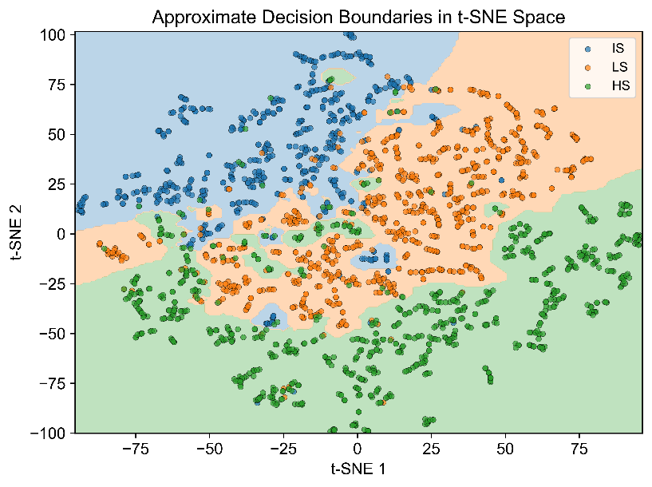
Figure 12 Visualization of the classification boundaries of the three HS–IS–LS deposit types based on t-SNE
t-SNE is a nonlinear dimensionality-reduction and visualization algorithm that is particularly adept at revealing manifold structures at different scales within complex datasets (Maaten and Hinton, 2008). t-SNE analysis of the preprocessed dataset shows that samples from the high-, intermediate-, and low-sulfidation deposits form relatively independent clusters in the two-dimensional embedding space, with clear classification boundaries (Figure 12). It is worth noting that even when SVM uses a linear kernel, its accuracy, precision, recall, and F1-score can be maintained at around 0.90. Therefore, the pyrite trace elements of the three deposit types are separable in the high-dimensional feature space, and it is feasible to delineate the intermediate-sulfidation deposits at the data level.
The reasonableness of missing-value imputation is one of the important factors for the credibility of a discriminative model. This study compared the distribution densities of the elements before and after imputation by the MissForest algorithm (Appendix 2). The results show that the main distributional characteristics of the element features were well preserved after imputation (Figure 13). When the missingness rate of an element is high, the algorithm performs conservative imputation, i.e., shrinkage toward the mean. To further quantify the imputation quality, experiments were conducted separately before and after imputation, taking advantage of TabPFN's ability to handle a small amount of missing values (Hollmann et al., 2025) . The results show that the accuracy was lower when using the pre-imputation data (0.979), and the corrected resampled t-test (t = −4.5673, p = 0.0014) indicates that the performance improvement is statistically significant.
Figure 13 Element density plots before and after MissForest imputation

4.2 Analysis of Classifier Performance and Applicable Scenarios
All seven models investigated in this study can effectively leverage pyrite trace-element data to accurately classify the subtypes of epithermal gold deposits. However, the classification accuracy differs among the models, which is mainly related to their algorithmic foundations, parameter settings, and degree of suitability for the data (Bergen et al., 2019). The seven models used in this study all performed well in the deposit discrimination task, with accuracy, precision, recall, and F1-score all exceeding 0.93 and macro-averaged AUC values all above 0.98 (Table 2), and TabPFN achieved the best results across all metrics. The corrected resampled t-test results show that TabPFN has a clear performance advantage in this task; FT-Transformer and CatBoost rank in the second tier; there is no significant difference among MLP, SVM, and HyperFast, whereas the performance of TabR exhibits obvious randomness (Figure 5). The four models MLP, SVM, HyperFast, and TabR, achieve good classification results but perform slightly worse than the three models mentioned above. In the noise tests (Figure 6), the accuracy declines of TabPFN, FT-Transformer, and CatBoost did not exceed 30%, and no overfitting behavior was observed. Studies have shown that MLP and SVM models exhibit excellent robustness to the quality of imputed data(Shadbahr et al., 2023). In practical applications, accurate prediction is a prerequisite for subsequent work. Therefore, a mixed error-imputation test was conducted (Figure 14). The results show that MLP, SVM, HyperFast, and TabR possess excellent anti-interference capability, outperforming TabPFN and FT-Transformer when faced with erroneous imputation.
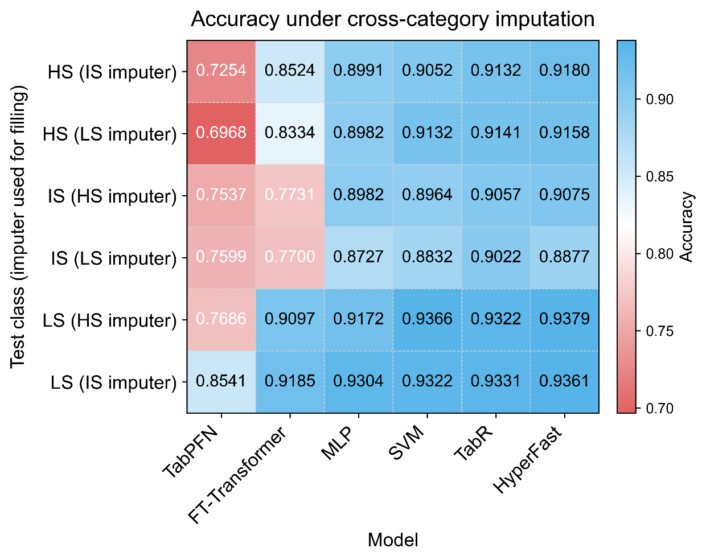
Figure 14 Discrimination results for unknown deposit classes under erroneous imputation
Consequently, TabPFN is the preferred model for distinguishing epithermal gold deposit subtypes in scenarios of refined scientific discrimination and large-scale geological mapping; FT-Transformer exhibits strong resistance to analytical errors and sampling noise and is suitable for processing raw field data with measured deviations; CatBoost requires neither missing-value handling nor hyperparameter tuning and is highly suited to the rapid preliminary screening of large batches of geochemical samples in the early stages of mineral exploration. MLP, SVM, HyperFast, and TabR are insensitive to the correctness of imputation and are therefore suitable for auxiliary discrimination throughout the entire workflow.

4.3 Genetic Constraints on the HS–IS–LS Deposits
The positive high values of Cu, Te, and Mo in pyrite of high-sulfidation deposits are their prominent discriminative characteristics (Figure 8). This feature is closely related to the extreme fluid environment of HS deposits, characterized by strong acidity (pH < 3), high oxygen fugacity ($f_{O_{2}}$), and high sulfur fugacity ($f_{S_{2}}$) (Hedenquist et al., 2000; Sillitoe & Hedenquist, 2003). In strongly acidic fluids, Cu can be transported in large quantities as stable chloride complexes (${CuCl}_{2}^{−}$) and enter the pyrite lattice by isomorphous substitution for Fe during sulfide precipitation (Reich et al., 2013). Meanwhile, a high-$f_{O_{2}}$ environment favors the formation of stable thio-complexes of Te, allowing Te to precipitate synchronously with Au during fluid boiling or mixing (Ciobanu et al., 2006). It is worth noting that although pyrite in HS deposits generally has high Au contents, its values vary widely (Figure 8). This may reflect the non-steady-state characteristics of fluid boiling and phase separation in magmatic hydrothermal systems. The dramatic changes in physicochemical conditions cause Au precipitation to be pulsatile, resulting in large differences in Au contents among pyrite grains of different generations or at different positions within the same generation (Simmons et al., 2005).
Compared with the HS and LS types, the most prominent features of the intermediate-sulfidation deposits in the SHAP plot are the negative contributions of Ni, Mo, Sb, and Co, as well as their overlap with the LS type in Te and Zn (Figure 8). IS fluids are generally neutral to weakly alkaline (pH≈5–7). Under such pH conditions, Co²⁺ and Ni²⁺ readily undergo hydrolysis or form carbonate precipitates, making it difficult for them to form stable complexes for long-distance transport as they do in strongly acidic (HS) or strongly reducing (LS) fluids, thereby leading to a relative depletion of Co and Ni in pyrite (Simmons et al., 2005). In neutral redox-transitional environments, Mo and Sb tend to form highly stable oxyanions (e.g., MoO₄²⁻, Sb(OH)₄⁻). These complexes have extremely high solubility in fluids and do not readily enter the sulfide lattice, resulting in significantly lower contents of these elements in IS-type pyrite than in LS-type deposits. The overlap of IS and LS types in Te and Zn reflects the continuity of fluid evolution.
Low-sulfidation deposits are characterized by the positive enrichment of Ni, Mo, Sb, and Co, and also show similarities with the HS type in Ni and Sb (Figure 8). Although LS fluids are neutral, they occur in strongly reducing environments and are often accompanied by intense fluid boiling or mixing with meteoric water (Simmons et al., 2005). Reducing conditions allow Co and Ni to be effectively transported as bisulfide complexes (e.g., ${Co(HS)}_{2}^{0}$) (Large et al., 2009). The H₂S degassing and pH fluctuations caused by fluid boiling destabilize the Mo and Sb oxyanion complexes, promoting their co-precipitation with pyrite. In addition, the lattice defects produced by the pervasive As enrichment in LS-type pyrite (Figure 8) also provide additional lattice sites for the enrichment of these elements (Reich et al., 2005). Compared with the high Ni and Sb contents in the HS type, which originate from the high dissolution capacity of strongly acidic fluids, the high Ni and Sb contents in the LS type are controlled by bisulfide-complex transport under reducing conditions and by boiling-precipitation mechanisms.

4.4 Limitations of the Study and Future Prospects
This study demonstrated that the intelligent discrimination of HS–IS–LS epithermal gold deposits can be achieved on the basis of pyrite trace elements and machine learning. Objectively, however, the study still has several limitations.
(1) The data used in this study are all derived from published literature, covering 17 typical epithermal gold deposits. Nevertheless, differences exist among the sampling locations, mineralization stages, analytical instruments, and detection-limit standards across the deposit samples from different literature sources, and the resulting systematic bias cannot be completely eliminated. At the same time, no field-measured data from unknown mining areas were collected for external validation, and the regional generalization ability of the models still requires further testing.
(2) Theoretically, as the number of samples approaches infinity, the training error of the model can converge to the true generalization error in the real world. Meanwhile, enriching the feature dimensions can enhance the model's ability to capture the multi-element synergistic constraints of geological processes. Therefore, increasing the sample size and expanding the element features can further enhance the generalization ability of the model.
(3) The performance of some models depends on the setting of their parameters; further efforts are needed to seek the global optimum to ensure that the model performance is fully realized.
(4) This study used only the trace elements of a single mineral, pyrite, as the research vehicle, without integrating multidimensional geological information such as petrographic features, fluid-inclusion microthermometry, and whole-rock geochemistry. The geochemical characteristics of a single mineral cannot fully reflect the complete picture of the hydrothermal metallogenic system.
Relying on machine learning to carry out intelligent mineral exploration is an important development direction in modern geology. This study is only an exploratory attempt toward the refined classification of epithermal deposits; more interdisciplinary and cross-cutting research will be conducted in the future to promote the development of ore deposit geology and metallogenic theory toward quantitative and intelligent directions.

5. Conclusions
(1) Based on the 12 screened pyrite trace elements, all seven machine learning models can achieve high-precision classification of high-, intermediate-, and low-sulfidation epithermal gold deposits, with accuracies all exceeding 0.93, demonstrating that pyrite trace elements possess strong genetic significance for ore deposits.
(2) The TabPFN model achieves the best overall performance in classifying the subtypes of epithermal gold deposits based on pyrite trace-element data (accuracy 0.998, AUC=1.000), and its classification capability is significantly superior to that of the other models.
(3) Cu, Au, Mo, Sb, Te, and Ni in pyrite are the core trace elements for distinguishing high-, intermediate-, and low-sulfidation epithermal gold deposits, and the differentiation patterns of these elements are closely related to metallogenic conditions such as oxygen fugacity, sulfur fugacity, fluid acidity–alkalinity, and salinity.

Acknowledgements

References
Abildin, Y., Xu, C., Dowd, P., and Adeli, A., 2023, Geometallurgical Responses on Lithological Domains Modelled by a Hybrid Domaining Framework: Minerals, v. 13, no. 7.
Agterberg, F. P., 2012, Multifractals and geostatistics: Journal of Geochemical Exploration, v. 122, p. 113–122.
Barkov, V., Schmidinger, J., Gebbers, R., and Atzmueller, M., 2026, Modern Neural Networks for Small Tabular Datasets: The New Default for Field‐Scale Digital Soil Mapping?: European Journal of Soil Science, v. 77, no. 2.
Bergen, K. J., Johnson, P. A., de Hoop, M. V., and Beroza, G. C., 2019, Machine learning for data-driven discovery in solid Earth geoscience: Science, v. 363, no. 6433.
Bishop, C. M., 1995, Training with noise is equivalent to Tikhonov regularization: Neural Comput., v. 7, no. 1, p. 108–116.
Börner, F., Keith, M., Smith, D. J., Barry, T. L., Neumann, T., and Klemd, R., 2021, Fingerprinting fluid evolution by trace elements in epithermal pyrite, Vatukoula Au-Te deposit, Fiji: Ore Geology Reviews, v. 137.
Caraballo, E., Beaudoin, G., and Dare, S., 2025, Trace element composition of chalcopyrite as a tool for deposit type discrimination from magmatic and hydrothermal settings: a machine learning approach: Mineralium Deposita, v. 61, no. 2, p. 299–326.
Cheng, Q., 2012, Singularity theory and methods for mapping geochemical anomalies caused by buried sources and for predicting undiscovered mineral deposits in covered areas: Journal of Geochemical Exploration, v. 122, p. 55–70.
Cherid, A., Aribi, N., Belaid, M. S., and Lebbah, Y., 2025, HyperFast: a spectral-spatial guided filtering framework for efficient UAV-borne hyperspectral crop classification: Applied Intelligence, v. 55, no. 16.
Christie, A. B., Simpson, M. P., Brathwaite, R. L., Mauk, J. L., and Simmons, S. F., 2007, Epithermal Au-Ag and Related Deposits of the Hauraki Goldfield, Coromandel Volcanic Zone, New Zealand: Economic Geology, v. 102, no. 5, p. 785–816.
Cooke, D., and Simmons, S., 2000, Characteristics and genesis of epithermal gold deposits: Reviews in Economic Geology, v. 13, p. 221–244.
Crabbé, J., and Schaar, M. v. d., Evaluating the robustness of interpretability methods through explanation invariance and equivariance, in Proceedings Proceedings of the 37th International Conference on Neural Information Processing Systems, New Orleans, LA, USA, 2023, Curran Associates Inc., p. Article 3127.
Einaudi, M., Hedenquist, J., and Inan, E., 2003, Sulfidation State of Fluids in Active and Extinct Hydrothermal Systems: Transitions from Porphyry to Epithermal Environments, Volume 10, p. 285–313.
Emmanuel, T., Maupong, T., Mpoeleng, D., Semong, T., Mphago, B., and Tabona, O., 2021, A survey on missing data in machine learning: Journal of Big Data, v. 8, no. 1, p. 140.
García-Laencina, P. J., Sancho-Gómez, J.-L., and Figueiras-Vidal, A. R., 2009, Pattern classification with missing data: a review: Neural Computing and Applications, v. 19, no. 2, p. 263–282.
Guan, H., Luosang, J., Gao, L., and Xie, F., 2025, Pyrite Trace-Element Signatures of Porphyry-Epithermal Systems in Xizang: Implications for Metallogenic Discrimination and Hydrothermal Evolution: Minerals, v. 15, no. 11.
Guidotti, R., Monreale, A., Ruggieri, S., Turini, F., Giannotti, F., and Pedreschi, D., 2018, A Survey of Methods for Explaining Black Box Models: ACM Comput. Surv., v. 51, no. 5, p. Article 93.
Gul, M. A., Zhang, H., Li, Y., Yang, X., Sun, C., Zhao, X., Ren, G., Kanwal, A., Hafeez, M., Yang, Y., Awan, R. S., and Faisal, M., 2025, Machine learning-driven classification of Pb Zn ore deposits using pyrite trace elements and isotopic signatures: A case study of the Gunga deposit: Journal of Geochemical Exploration, v. 272.
He, H., Zeng, T., Zhang, H., Li, P., Hou, D., Shen, Q., Guan, K., Pan, J., Yin, Z., Sun, J., Huang, X., and Bian, X., 2026, Identification of Mineralizing Lithologies Driven by Interpretable Machine Learning on Multisource Geochemical Data: A Case Study from the Qin–Hang Metallogenic Belt: Natural Resources Research.
Hedenquist, J., Arribas, A., and Gonzalez-Urien, E., 2000, Exploration for Epithermal Gold Deposits: Reviews in Economic Geology, v. 13, p. 245–277.
Heinrich, C. A., 2005, The physical and chemical evolution of low-salinity magmatic fluids at the porphyry to epithermal transition: a thermodynamic study: Mineralium Deposita, v. 39, no. 8, p. 864–889.
Hollmann, N., Muller, S., Purucker, L., Krishnakumar, A., Korfer, M., Hoo, S. B., Schirrmeister, R. T., and Hutter, F., 2025, Accurate predictions on small data with a tabular foundation model: Nature, v. 637, p. 319–326.
Hooker, S., Erhan, D., Kindermans, P.-J., and Kim, B., A Benchmark for Interpretability Methods in Deep Neural Networks, in Proceedings Neural Information Processing Systems2018.
Hornung, R. W., and Reed, L. D., 1990, Estimation of Average Concentration in the Presence of Nondetectable Values: Applied Occupational and Environmental Hygiene, v. 5, no. 1, p. 46–51.
Hron, K., Templ, M., and Filzmoser, P., 2010, Imputation of missing values for compositional data using classical and robust methods: Computational Statistics & Data Analysis, v. 54, no. 12, p. 3095–3107.
Jaffari, Z. H., Abbas, A., Kim, C. M., Shin, J., Kwak, J., Son, C., Lee, Y. G., Kim, S., Chon, K., and Cho, K. H., 2024, Transformer-based deep learning models for adsorption capacity prediction of heavy metal ions toward biochar-based adsorbents: J Hazard Mater, v. 462, p. 132773.
Junaid, K. P., Kiran, T., Gupta, M., Kishore, K., and Siwatch, S., 2025, How much missing data is too much to impute for longitudinal health indicators? A preliminary guideline for the choice of the extent of missing proportion to impute with multiple imputation by chained equations: Population Health Metrics, v. 23, no. 1.
Kapoor, S., and Narayanan, A., 2023, Leakage and the reproducibility crisis in machine-learning-based science: Patterns, v. 4, no. 9, p. 100804.
Kaufman, S., Rosset, S., Perlich, C., and Stitelman, O., 2012, Leakage in data mining: ACM Transactions on Knowledge Discovery from Data, v. 6, no. 4, p. 1–21.
Kohavi, R., A study of cross-validation and bootstrap for accuracy estimation and model selection, in Proceedings Proceedings of the 14th international joint conference on Artificial intelligence - Volume 2, Montreal, Quebec, Canada, 1995, Morgan Kaufmann Publishers Inc., p. 1137–1143.
Large, R. R., Danyushevsky, L., Hollit, C., Maslennikov, V., Meffre, S., Gilbert, S., Bull, S., Scott, R., Emsbo, P., Thomas, H., Singh, B., and Foster, J., 2009, Gold and Trace Element Zonation in Pyrite Using a Laser Imaging Technique: Implications for the Timing of Gold in Orogenic and Carlin-Style Sediment-Hosted Deposits: Economic Geology, v. 104, no. 5, p. 635–668.
Lundberg, S. M., and Lee, S.-I., A Unified Approach to Interpreting Model Predictions, in Proceedings Neural Information Processing Systems2017, Volume 30.
Luo, X., Ci, X., Sun, J., Dan, C., Chi, P., and Cui, R., 2025, Enhancing reservoir parameter prediction workflows via advanced core data augmentation: Marine and Petroleum Geology, v. 182.
Luo, Z., Farahbakhsh, E., Müller, R. D., and Zuo, R., 2024, Multivariate statistical analysis and bespoke deviation network modeling for geochemical anomaly detection of rare earth elements: Applied Geochemistry, v. 174.
Maaten, L. v. d., and Hinton, G. E., 2008, Visualizing Data using t-SNE: Journal of Machine Learning Research, v. 9, p. 2579–2605.
Mauk, J. L., and Simpson, M. P., 2007, Geochemistry and Stable Isotope Composition of Altered Rocks at the Golden Cross Epithermal Au-Ag Deposit, New Zealand: Economic Geology, v. 102, no. 5, p. 841–871.
Meng, Y.-M., Huang, X.-W., Hu, R., Beaudoin, G., Zhou, M.-F., and Meng, S., 2024, Deposit type discrimination based on trace elements in sphalerite: Ore Geology Reviews, v. 165.
Mondal, A., Saha, R., Upadhyay, D., Mallick, S. P., Pruseth, K. L., and Chakraborty, A., 2026, A machine learning approach in type-discrimination and exploration of gold deposits using pyrite trace element chemistry: Journal of Geochemical Exploration, v. 284.
Palarea-Albaladejo, J., and Martín-Fernández, J. A., 2015, zCompositions — R package for multivariate imputation of left-censored data under a compositional approach: Chemometrics and Intelligent Laboratory Systems, v. 143, p. 85–96.
Qin, Y., Kong, H., Liu, B., Jiang, H., Hou, X., and Huang, J., 2023, Distinguishing the Type of Ore-Forming Fluids in Gold Deposits Using Pyrite Geochemistry and Machine Learning: Natural Resources Research, v. 33, no. 1, p. 107–127.
Queffurus, M., and Barnes, S.-J., 2015, A review of sulfur to selenium ratios in magmatic nickel–copper and platinum-group element deposits: Ore Geology Reviews, v. 69, p. 301–324.
Reimann, C., and Filzmoser, P., 2000, Normal and lognormal data distribution in geochemistry: death of a myth. Consequences for the statistical treatment of geochemical and environmental data: Environmental Geology, v. 39, no. 9, p. 1001–1014.
Richards, J. P., 2011, Magmatic to hydrothermal metal fluxes in convergent and collided margins: Ore Geology Reviews, v. 40, no. 1, p. 1–26.
Rouxel, O., Ludden, J., Carignan, J., Marin, L., and Fouquet, Y., 2002, Natural variations of Se isotopic composition determined by hydride generation multiple collector inductively coupled plasma mass spectrometry: Geochimica et Cosmochimica Acta, v. 66, no. 18, p. 3191–3199.
Rudin, C., 2019, Stop Explaining Black Box Machine Learning Models for High Stakes Decisions and Use Interpretable Models Instead: Nat Mach Intell, v. 1, no. 5, p. 206–215.
Shadbahr, T., Roberts, M., Stanczuk, J., Gilbey, J., Teare, P., Dittmer, S., Thorpe, M., Torné, R. V., Sala, E., Lió, P., Patel, M., Preller, J., Selby, I., Breger, A., Weir-McCall, J. R., Gkrania-Klotsas, E., Korhonen, A., Jefferson, E., Langs, G., Yang, G., Prosch, H., Babar, J., Escudero Sánchez, L., Wassin, M., Holzer, M., Walton, N., Lió, P., Rudd, J. H. F., Mirtti, T., Rannikko, A. S., Aston, J. A. D., Tang, J., Schönlieb, C.-B., and Collaboration, A.-C., 2023, The impact of imputation quality on machine learning classifiers for datasets with missing values: Communications Medicine, v. 3, no. 1, p. 139.
Sillitoe, R., and Hedenquist, J., 2003, Linkages between Volcanotectonic Settings, Ore-Fluid Compositions, and Epithermal Precious Metal Deposits, Volume 10, p. 315–343.
Sillitoe, R. H., 2010, Porphyry Copper Systems: Economic Geology, v. 105, no. 1, p. 3–41.
Steadman, J. A., Large, R. R., Olin, P. H., Danyushevsky, L. V., Meffre, S., Huston, D., Fabris, A., Lisitsin, V., and Wells, T., 2021, Pyrite trace element behavior in magmatic-hydrothermal environments: An LA-ICPMS imaging study: Ore Geology Reviews, v. 128.
Stekhoven, D. J., and Bühlmann, P., 2012, MissForest--non-parametric missing value imputation for mixed-type data: Bioinformatics, v. 28, no. 1, p. 112–118.
Sun, G.-T., and Zhou, J.-X., 2022, Application of Machine Learning Algorithms to Classification of Pb–Zn Deposit Types Using LA–ICP–MS Data of Sphalerite: Minerals, v. 12, no. 10.
Sun, Y., Li, J., Xu, Y., Zhang, T., and Wang, X., 2023, Deep learning versus conventional methods for missing data imputation: A review and comparative study: Expert Systems with Applications, v. 227.
Vikent’ev, I. V., Belogub, E. V., Moloshag, V. P., and Eremin, N. I., 2019, Selenium in Volcanogenic Massive Sulfide Ores: Doklady Earth Sciences, v. 484, no. 1, p. 40–44.
Wager, S., Wang, S., and Liang, P., Dropout Training as Adaptive Regularization, in Proceedings Advances in neural information processing systems2013.
Wang, L., Chiaradia, M., Qin, K.-Z., Hui, K.-X., Li, Z.-Z., Cao, M.-J., Song, G.-X., Pang, X.-Y., Shan, P.-F., and Li, G.-M., 2024a, Magmatic Controls on Au- and Ag-Rich Intermediate-Sulfidation Epithermal Deposits from Northeast China: Economic Geology, v. 119, no. 8, p. 1913–1936.
Wang, L., Qin, K.-Z., Song, G.-X., and Li, G.-M., 2019, A review of intermediate sulfidation epithermal deposits and subclassification: Ore Geology Reviews, v. 107, p. 434–456.
Wang, P., Su, S.-G., Wang, G.-Z., Dong, Y.-Y., and Yu, D.-l., 2024b, Discrimination of deposit types using magnetite geochemistry based on machine learning: Ore Geology Reviews, v. 170.
Yu, L., and Liu, H., 2004, Efficient Feature Selection via Analysis of Relevance and Redundancy: J. Mach. Learn. Res., v. 5, p. 1205–1224 , numpages = 1220.
Zeng, Q., Shu, Q., Wang, Q., Zhang, Q., Zhao, Z., Niu, X., Yu, F., Zhang, L., Deng, J., and Liu, H., 2025, Genetic types of Zn-Pb deposits revealed by sphalerite geochemistry: American Mineralogist, v. 110, no. 11, p. 1756–1769.
Zhang, P., Zhang, Z., Yang, J., and Cheng, Q., 2022, Machine Learning Prediction of Ore Deposit Genetic Type Using Magnetite Geochemistry: Natural Resources Research, v. 32, no. 1, p. 99–116.
Zhang, X., Niu, Y., Zhu, G., and Wan, S., 2024a, Application of deep neural network to discriminating chalcopyrite deposits, ore types, and textures: Journal of Geochemical Exploration, v. 259.
Zhang, X., Wang, D., Ma, H., Dong, S., Wang, Z., and Wang, Z., 2024b, Application of Machine Learning to Research on Trace Elemental Characteristics of Metal Sulfides in Se-Te Bearing Deposits: Minerals, v. 14, no. 6.
Zhang, Y., Peng, Y., Gu, X., Wang, Q., and Song, M., 2024c, Ore-forming process of the Xiaoyuzan gold deposit in the Western Tianshan, Northwest China: Constraints from mineralogy and S isotopes of sulfides: Ore and Energy Resource Geology, v. 17.
Zhao, J., Chen, S., and Zuo, R., 2016, Identifying geochemical anomalies associated with Au–Cu mineralization using multifractal and artificial neural network models in the Ningqiang district, Shaanxi, China: Journal of Geochemical Exploration, v. 164, p. 54–64.
陈衍景, 倪培, 范宏瑞, Pirajno, F., 赖勇, 苏文超, and 张辉, 2007, 不同类型热液金矿系统的流体包裹体特征: 岩石学报, no. 9, p. 2085–2108.
邓依, 张静, 钟日晨, 何西恒, and 王潇逸, 2024, 基于机器学习的主成分分析方法在金矿类型判别中的应用：以黄铁矿元素地球化学特征为例: 岩石学报, v. 40, no. 06, p. 1801–1816.

